Nabeel Ahmed
D209 Task 2 Performance Assessment
04/30/2025

- Research Question:
  - Can we predict a customer's MonthlyCharge based on their demographic and service usage data using ridge regression?
  - The goal of the data analysis is to build a model that predicts a customer's MonthlyCharge using demographic and service usage variables.
- Method Justification:
  - Ridge regression analyzes the data by applying a penalty to the coefficients to reduce overfitting while minimizing the residual sum of squares. It uses all predictor variables and shrinks their coefficients toward zero without eliminating any variables. The expected outcome is a model that accurately predicts MonthlyCharge with reduced variance.
(Yadav)
  - One assumption of ridge regression is that there is a linear relationship between
the predictors and the target variable.
  - Library:
    - pandas: Used for loading and manipulating the dataset.
    - numpy: Used for numerical operations needed during model development.
    - scikit-learn: Provides the Ridge regression model, data preprocessing
tools, and performance metrics.
    - matplotlib: Used for visualizing model performance if needed.
- Data Preparation:
  - The data preprocessing goal is to ensure all predictor variables are numeric and
scaled properly to meet the requirements of ridge regression.
  - Relevant Variables and Types
    - Numeric Variables:
      - Lat
      - Lng
      - Population
      - Children
      - Age
      - Income
      - Outage_sec_perweek
      - Contacts
      - Yearly_equip_failure
      - Tenure
      - MonthlyCharge (target variable)
      - Bandwidth_GB_Year
    - Categorical Variables:
      - InternetService
      - Techie
      - Contract
      - Port_modem
      - Tablet
      - Phone
      - Multiple
      - OnlineSecurity
      - OnlineBackup
      - DeviceProtection
      - TechSupport
      - StreamingTV
      - StreamingMovies
      - PaperlessBilling
      - PaymentMethod
      - Gender
      - Marital

  - Data Preparation Steps:
    - Drop Irrelevant Columns: Columns that are identifiers (such as Customer
ID, ZIP code, or coordinates) or unrelated to the prediction (such as city
name or random survey items) were removed to reduce noise in the model and focus only on meaningful predictors.
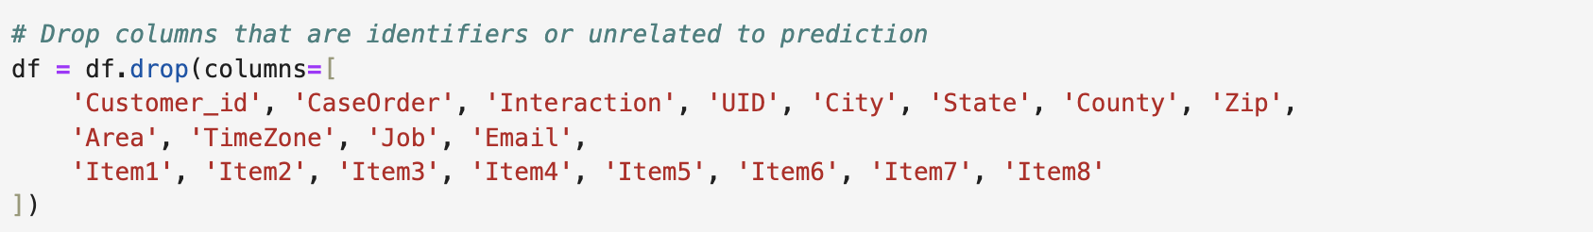
    - One-hot encode categorical variables: Machine learning models like ridge regression require all input variables to be numeric. So, categorical
variables (like InternetService or Contract type) were converted into
binary (0 or 1) columns using one-hot encoding.
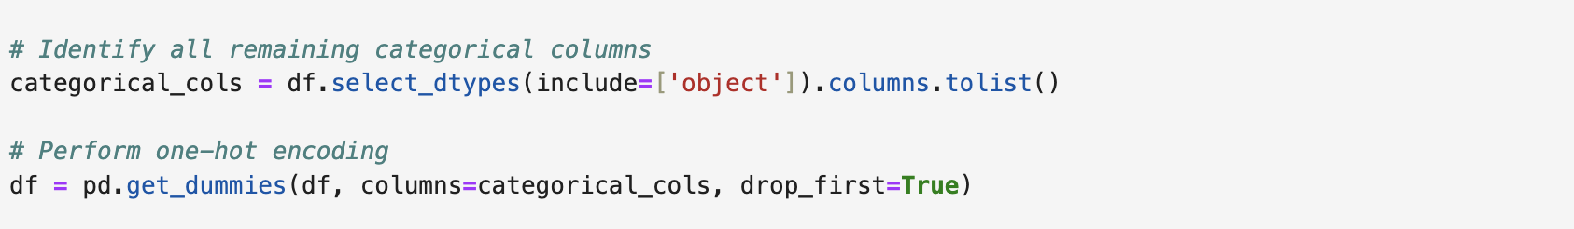
    - Separate features and target variable: The dataset was split into features
(X) and the target variable (y), which is the variable we are trying to
predict — MonthlyCharge.
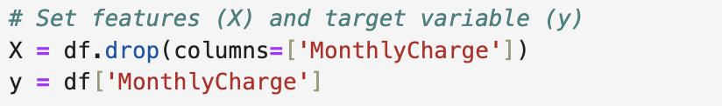
    - Scale the feature variables: Feature variables were standardized so that
they all have the same scale. This is important for ridge regression because the algorithm is sensitive to the magnitude of the input variables.
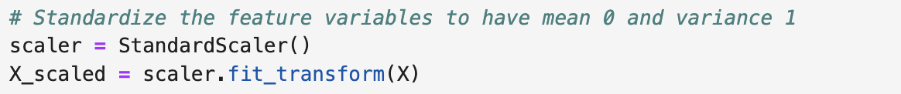
    - Create and Save Cleaned Data: We combine the scaled features and the
encoded target variable into a single DataFrame. Then we save it as a new file for further analysis in the next steps.
  - Cleaned CSV file attached to submission called:
“cleaned_churn_data.csv”
- Analysis:
  - Files are attached to submission.
  - I used ridge regression for the analysis. It adds a penalty to the model to keep the coefficients small and avoid overfitting. This way, the model stays general and
works well even if there are a lot of predictors. I looked at the model’s
coefficients, the predicted values, and the evaluation metrics
(MSE and R-squared) to check how well it performed.
(Jain)
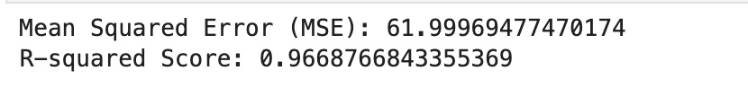
  - Code for Above results:
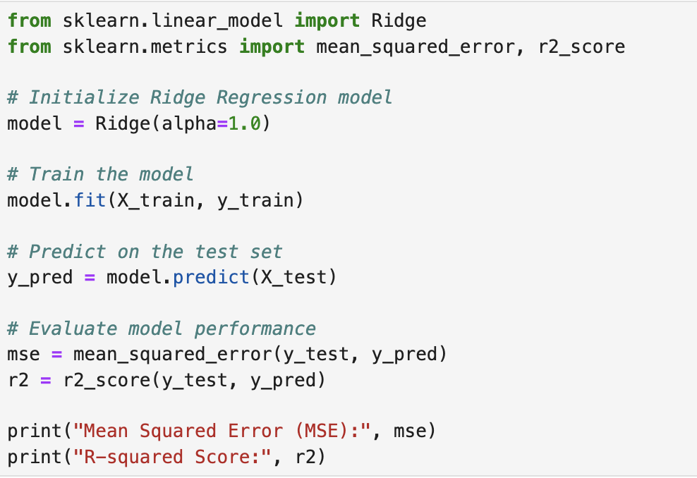
- Data Summary and Implication:
  - The The R-squared score of the model was 0.967, meaning the model explains
96.7% of the variance in MonthlyCharge. The Mean Squared Error (MSE) was
61.99, showing the average squared difference between predicted and actual
charges.
  - The model predicts MonthlyCharge accurately based on the features used. A high R-squared and low MSE indicate strong model performance. This means the
company can use the model to estimate expected monthly charges and monitor for any unusual values.
  - One limitation is that ridge regression assumes linear relationships between
variables. If there are any nonlinear patterns in how MonthlyCharge is influenced, this model might miss them.
  - The company should use this model to predict expected MonthlyCharge values
for both new and current customers. If any customers have charge amounts that
are way off from the predicted value, they can be reviewed more closely — either for billing issues or to find upsell opportunities. It’s a practical way to stay on top of revenue forecasting and customer trends.
- Panopto Link:
Folder: https://wgu.hosted.panopto.com/Panopto/Pages/Sessions/List.aspx#folderID=%22dcfdf6dd-9e05-4665-b1b6-ac72018a20ab%22
Video: https://wgu.hosted.panopto.com/Panopto/Pages/Viewer.aspx?id=5134b0a8-4544-4b4b-b6ff-b2d0000c17c5
- Sources:
Jain, A. (2025, March 10). Ridge and lasso regression in python. Analytics Vidhya. https://www.analyticsvidhya.com/blog/2016/01/ridge-lasso-regression-python-complete-tutorial/
Stojiljković, M. (2025, January 29). Split your dataset with scikit-learn’s train_test_split(). Real Python. https://realpython.com/train-test-split-python-data/
Yadav, A. (2024, November 14). Ridge regression implementation in Python. Medium. https://medium.com/biased-algorithms/ridge-regression-implementation-in-python-dddd50324263

